Data modeling

Conceptual

Logical

Physical

CRUD Matrix

Data modeling goals

1. Spread data evenly around the cluster. Paritions are distributed around the cluster based on a hash of the partition key. To distribute work across nodes, it’s desirable for every node in the cluster to have roughly the same amount of data.
2. Minimize the number of partitions read. Partitions are groups of columns that share the same partition key. Since each partition may reside on a different node, the query coordinator will generally need to issue separate commands to separate nodes for each partition we query.
3. Satisfy a query by reading a single partition. This means we will use roughly one table per query. Supporting multiple query patterns usually means we need more than one table. Data duplication is encourage

**Primary Key**

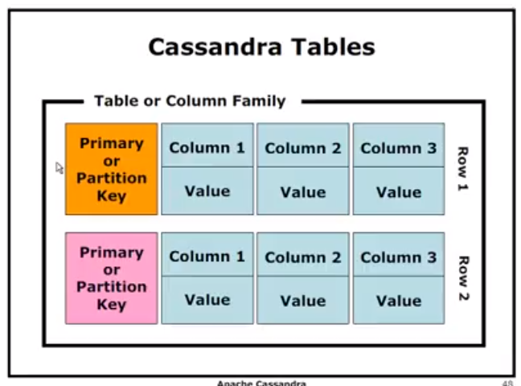

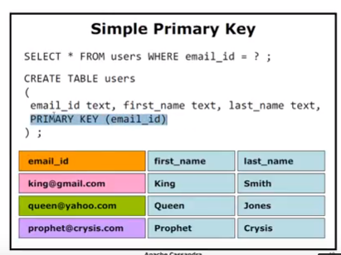

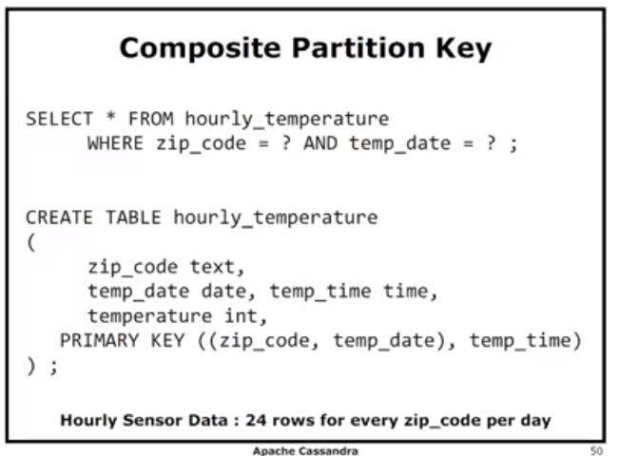

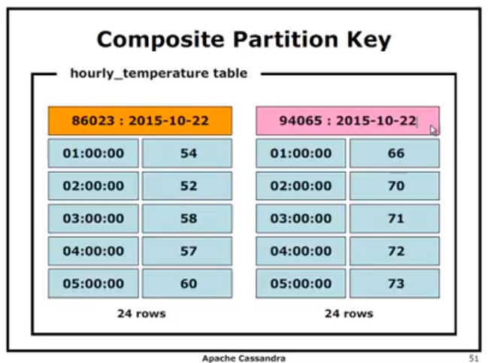

**Think usefullness every 10 sec temp captured**

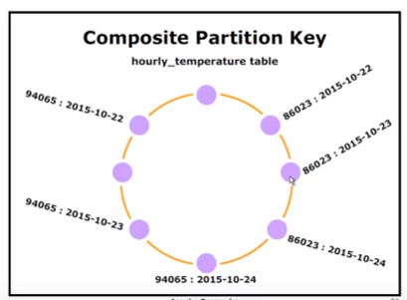

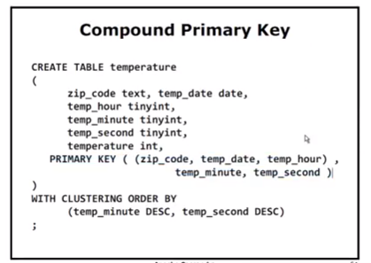

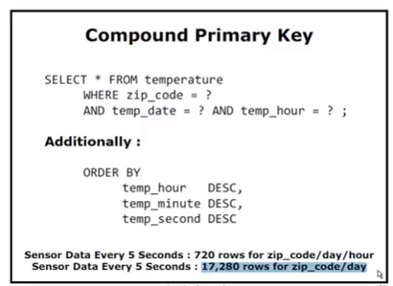

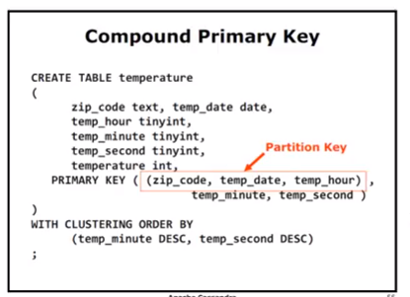

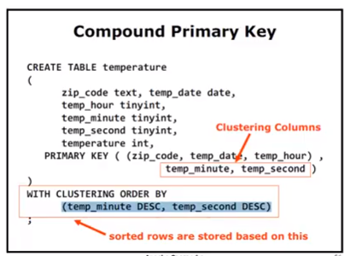

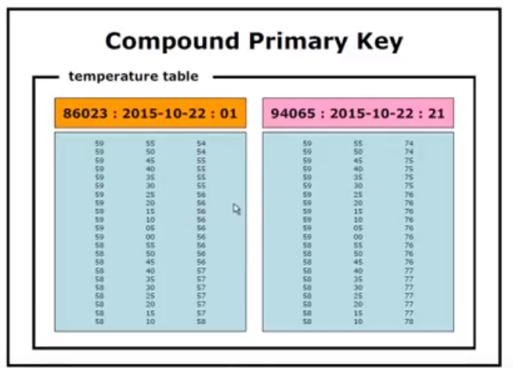

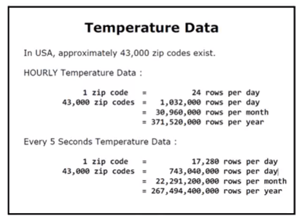

**Another example**

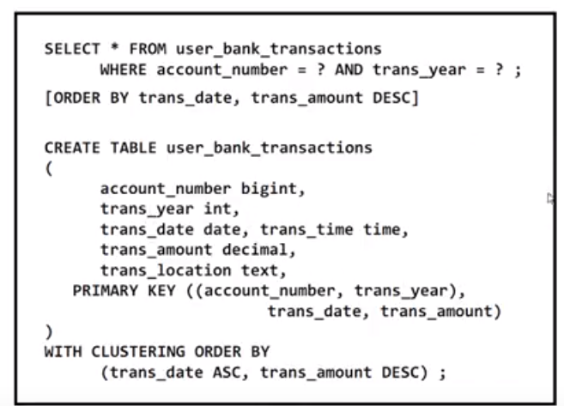

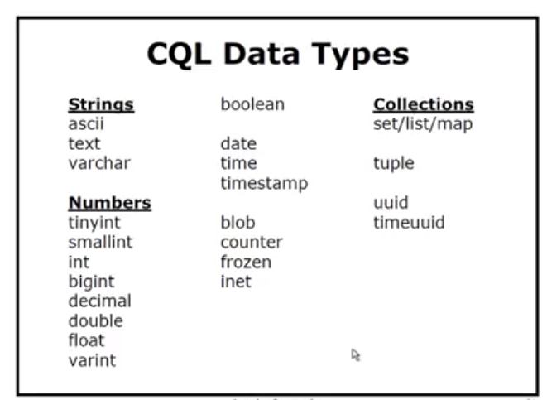

**Cassandra Automatic Data Expiration:**

The Automatic Data Expiration is one of the features of NoSQL Cassandra Database.  
You can set an expiration time in second to expire a particular data.  
You can set Time to Live (ttl) value in seconds.

You can change TTL value by re-insert the data with new TTL value.  
The actual insertion is kind of INSERT or UPDATE because it checks the previous data version and accordingly it performs the action.  
You can set the TTL value in both INSERT and UPDATE statements.

Automation Expiration of The Data, real-time application use like any e-commerce product is declaring different offers on products and each offer should expire at a specific time.  
In this kind of application, we can use the feature like the automation expiration of the Data.

|  |  |
| --- | --- |
|  | CREATE TABLE IF NOT EXISTS tbl_Employee  (    EmpID INT PRIMARY KEY    ,EmpFirstName VARCHAR    ,EmpLastName VARCHAR    ,EmpSalary INT  ); |
|  | INSERT INTO tbl_Employee  (EmpID,EmpFirstName,EmpLastName,EmpSalary)  VALUES  (1,'Anvesh','Patel',50000) USING TTL 20; |
|  |  |